Detailed Project Report

Project -1

Problem Statement

To build a regression model to predict the price of product based on evaluating various factors including historical data, supplier details, current market

Value of the project

* Price prediction can help with budget allocation
* Helps eliminate suppliers overcharging and also overspending from the client side
* Reduces negotiation time leading to delivery of materials on-time
* Reduces manual work load

Work Flow Diagram

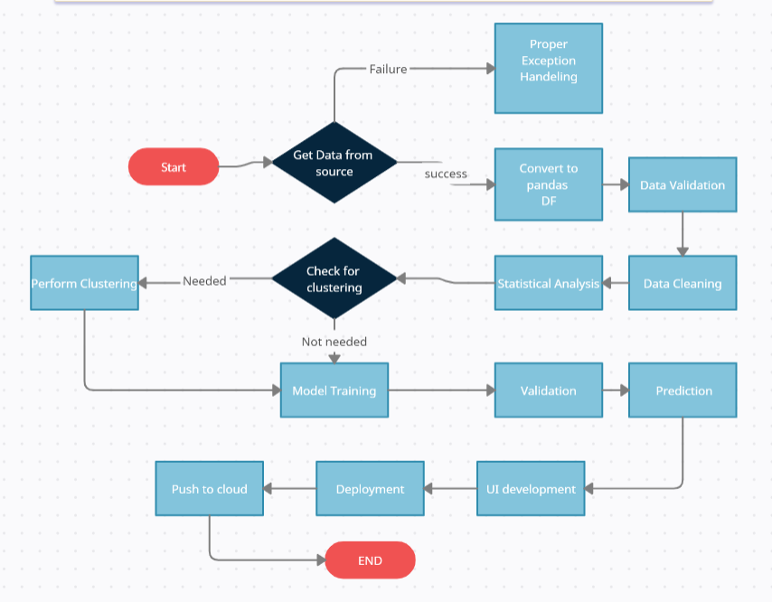

Core Tech Stack

Model Training:

* The data is exported in csv format for training
* EDA is performed to get insights about the data and also identify distribution, outliers, trend
* Check for missing values/null values in the columns and treat them if found
* Convert our text and categorical data to numbers. This process is called feature extraction or featurization
* Perform Standard Scalar to scale down the values.
* Different regression models will be performed one by one and their performance will be evaluated

Prediction:

* The data is exported in csv format for training
* The same pre-processing techniques are performed on this data
* Once the predictions using the regression models are done, the same are saved in csv format and shared.

Technology Used

|  |  |
| --- | --- |
| IDE | Pycharm |
| Front End | HTML/CSS/JS/React |
| Backend | Python Django |
| Database | Cassandra |
| Deployment | AWS |
| Version Control | Github |

Dashboarding

Tableau/ Power BI used for dashboard creation.

Dashboard will display certain KPIs showing summary and on charts the progress will be

included over time

Monitoring

If errors are encountered, the same will be communicated and the errors will be logged into the database which will be debugged.

Project -2

Problem Statement

To build a model to predict the customer churn using a telecom dataset

Value of the project

* Predicting customers overall satisfaction as well as their experience with service quality
* Identifying potential network issues, competitive threats, and at-risk customers
* Identifying the negative customer experience trends and reducing attrition levels
* Creating new opportunities for cross-selling and upselling
* Segment the customers based on behavior and demographics to improve retention
* Deliver tailored promotions and offers to positively influence their behavior

Work Flow Diagram



Core Tech Stack

Model Training:

* The data is exported in csv format for training
* EDA is performed to get insights about the data and also identify distribution, outliers, trend
* Check for missing values/null values in the columns and treat them if found
* Convert our text and categorical data to numbers. This process is called feature extraction or featurization
* Perform Standard Scalar to scale down the values.
* Different regression models (Logistic Regression, Random Forest) will be performed one by one and their performance will be evaluated

Prediction:

* The data is exported in csv format for training
* The same pre-processing techniques are performed on this data
* Once the predictions using the regression models are done, the same are saved in csv format and shared.

Technology Used

|  |  |
| --- | --- |
| IDE | Pycharm |
| Front End | HTML/CSS/JS/React |
| Backend | Python Django |
| Database | Cassandra |
| Deployment | AWS |
| Version Control | Github |

Dashboarding

Tableau/ Power BI used for dashboard creation.

Dashboard will display certain KPIs showing summary and on charts the progress will be

included over time

Monitoring

If errors are encountered, the same will be communicated and the errors will be logged into the database which will be debugged.